**FIT – Spain tour**

Madrid · Sevilla · Málaga · Valencia · Barcelona

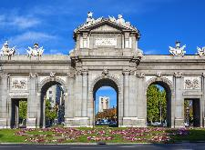 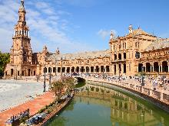 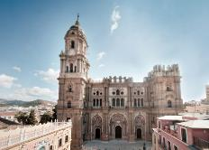 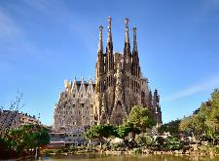

**day 1 Madrid**

arrival at Madrid airport.   
**private transfer** to hotel.

**Madrid sightseeing** based on a hop on hop off bus.

highlights: Gran Vía, Plaza de España, Habsburg old quarter, Puerta del Sol, Puerta de Alcalá, Columbus square with a brief stop at Madrid Hard Rock Café, Paseo de la Castellana and the Real Madrid stadium, Santiago Bernabéu (tour of the stadium available), Plaza Castilla, Fountain of Cibeles.

overnight at hotel in Madrid.

**day 2 Madrid - Sevilla**

breakfast at the hotel and check out.

half day **Toledo** **excursion**.

***Toledo*** *is one of the Spanish cities with the greatest wealth of monuments. known as the* ***“city of the three cultures”****, because Christians, Arabs and Jews lived together there for centuries, behind its walls Toledo preserves an artistic and cultural legacy in the form of churches, palaces, fortresses, mosques and synagogues.*

*Toledo distance: 70 km from Madrid.*

**private transfer** to Madrid train station.

**transfer** by high speed train from Madrid to Sevilla.

arrival at Sevilla train station.   
**private transfer** to hotel.

overnight at hotel in Sevilla.

**day 3 Sevilla**

breakfast at the hotel.

full day **Córdoba excursion** based on regular basis.

*Jews, Muslims and Christians have left a definite mark, enriching the city throughout centuries and making Córdoba a city of tolerance. this cultural richness is epitomized in the* ***Mosque of Córdoba.*** *after the visit to the mosque, enjoy a walk through the nearby* ***Jewish Quarter*** *and the* ***Calleja de las Flores****. short visit to the only remaining synagogue of the city.*

overnight at hotel in Sevilla.

**day 4 Sevilla - Malaga**

breakfast at the hotel and check out.

half day **Sevilla sightseeing** based on regular basis.

*the tour starts at the* ***Isla de la Cartuja*** *which was chosen as the site for the Expo’92, an appropriate reflection of the world at the end of the 20th century. laid out in 1929 for the Ibero-American exhibition, the* ***Plaza de España*** *and the adjoining* ***Maria Luisa Park*** *are among the most pleasant and impressive public spaces in Spain. located east of the cathedral, they are a perfect base from where to explore the highlights of the city. nearby is Sevilla’s old Jewish quarter, the barrio de Santa Cruz with its narrow white alleys, flowered patios and wrought ironed balconies.***private transfer** from hotel to train station.   
**transfer** by train from Sevilla to Malaga. **private transfer** from Malaga train station to hotel.

overnight at hotel in Malaga.

**day 5 Malaga**

breakfast at the hotel.

hop on - hop off bus in **Malaga**.

*known as the capital of* ***Costa del Sol****, Malaga is the major coastal city of Andalucía. founded by the Phoenicians more than 3000 years ago and later conquered by Carthaginians, Romans, Visigoths and Moors. Malaga has a colourful history which is well preserved in its monuments and remains around town. today Malaga is a cosmopolitan city, which apart from the tourist industry, has Spain’s second largest port and third largest international airport.*

overnight at hotel in Malaga.

**day 6 Malaga - Valencia**

breakfast at the hotel and check out.

**private transfer** from hotel to Malaga train station.

**transfer** by train from Malaga to Valencia.

arrival at Valencia train station.   
**private transfer** to hotel in Valencia.

overnight at hotel in Valencia.

**day 7 Valencia**

breakfast at the hotel.

hop on - hop off bus in **Valencia**.

*explore Valencia, through a visit to the city’s most important monuments, most of them located within walking distance from the city’s main square:*

*visitors will discover: council square, central market, silk exchange “La Lonja”, cathedral, Turia river bed garden, City of Arts & Sciences.*

overnight at hotel in Valencia.

**day 8 Valencia - Barcelona**

breakfast at the hotel and check out.

**private transfer** from hotel to Valencia train station.

**transfer** by train from Valencia to Barcelona.

arrival at Barcelona train station.   
**private transfer** to hotel.

half day **Barcelona sightseeing** on regular basis.

*ideal tour to cover the very best of Barcelona in a day. enjoy the outstanding views from* ***Montjuic Hill****, visit* ***Sagrada Familia*** *and Passeig de Grácia plus the* ***Port****,* ***Olympic Ring and Poble Espanyol.***

overnight at hotel in Barcelona.

**day 9 Barcelona**

breakfast at the hotel.

half day **Montserrat excursion** based on regular basis.

***Montserrat*** *and the* ***Penedés region*** *are symbolic of the two poles of the Catalan character: the spiritual and the celebratory. Montserrat, an imposing rocky outcrop, smoothed away by years of wind and rain, is the holy mountain of Catalonia, which houses the revered image of the black virgin.*

overnight at hotel in Barcelona.

**day 10 Barcelona**

breakfast at the hotel and check out.

**leisure time** in the Catalan capital, enjoy the weather and cuisine in this charming and cosmopolitan city, or go shopping on the famous **Las Ramblas.**

**private transfer** to Barcelona airport.

**end of services**

**prices**

|  |  |  |  |
| --- | --- | --- | --- |
| **price per person & package** | **Nov - Mar** | **Apr – Oct** | **Jul - Aug** |
| **standard class** | **1.020 €** | **1.120 €** | **1.099 €** |
| child standard price  (up to 12 yrs) | **360 €** | **370 €** | **360 €** |
| single supplement | **275 €** | **325 €** | **305 €** |
| **first class** | **1.085 €** | **1.215 €** | **1.155 €** |
| child first price  (up to 11 yrs) | **295 €** | **310 €** | **295 €** |
| single supplement | **335 €** | **445 €** | **390 €** |
| **superior** | **1.325 €** | **1.595 €** | **1.441 €** |
| child superior price  (up to 11 yrs) | **465 €** | **570 €** | **560 €** |
| single supplement | **515 €** | **745 €** | **610 €** |

* prices per person based on double room & bb basis. taxes included. valid for minimum 2 traveling pax. prices for children sharing room with 2 adults.

* prices subject to availability and possible fluctuations in any of the requested services at the time of final booking.

**validity**: **until October 2020.**

**inclusions:**

|  |  |  |  |  |
| --- | --- | --- | --- | --- |
| **city & nights** | **transfers** | **sightseeing on SIC basis** | **meals** | **24h. phone**  **assistance** |
| **1n Madrid** | private apt-htl-station | Madrid sightseeing  half day Toledo excursion | breakfast |
| **2n Sevilla** | private station-htl-station | Sevilla sightseeing  full day Córdoba excursion | breakfast |
| **2n Malaga** | private station-htl-station | hop on hop off bus | breakfast |
| **2n Valencia** | private station-htl-station | hop on hop off bus | breakfast |
| **2n Barcelona** | private station-htl-apt | Barcelona sightseeing *including entrance fee to Sagrada Familia and Poble Espanyol*  half day Montserrat excursion | breakfast |

**prices do not include:**

* regional tourist tax.
* tips and guests’ extras.
* any other service not mentioned on the programme/ itinerary described.
* train tickets, please find supplements below:
  + *AVE high speed train Madrid – Sevilla:  
    per person on tourist class:* ***from 77 €*** *(+ 4% handling fee)*
  + *AVANT train Sevilla – Malaga:  
    per person on tourist class:* ***from 45 €*** *(+ 4% handling fee)*
  + *AV train Malaga – Valencia:  
    per person on tourist class:* ***from 74 €*** *(+ 4% handling fee)*
  + *EUROMED train Valencia - Barcelona:  
    per person on tourist class:* ***from 46 €*** *(+ 4% handling fee)*
* **transportation to sightseeing meeting points is not included, we recommend the use of public transportation or taxi.**

**optional supplements**:

|  |  |  |
| --- | --- | --- |
| C:\Users\marketing2\Downloads\camp-nou.jpg  **football tickets**  **on request** (prices average 48-250 €) | C:\Users\marketing2\Downloads\Camp02.jpg  **Barça – Camp Nou stadium tour**  adult: 26 €  child (6-13): 21 €  *\*with time and date given* | C:\Users\marketing2\AppData\Local\Microsoft\Windows\INetCache\Content.Word\madrid-entrada-santiago-bernabeu.jpg  **Real Madrid stadium tour**  adult: 25 €  child (6-13):18 € |
| C:\Users\marketing2\AppData\Local\Microsoft\Windows\INetCache\Content.Word\Flamenco-Madrid-400x300.jpg  **flamenco show & dinner in Madrid**  adult: 63 € (vegetarian menu and special children menu available) | C:\Users\marketing2\Downloads\crucero-por-el-guadalquivir-1000-1000x580.jpg  **Guadalquivir cruise** 1h duration  adults: 16€  children (0-12): free | C:\Users\marketing2\Downloads\flamenco-sevilla.jpg  **flamenco show & drink in Sevilla**  from 28 € |
| C:\Users\marketing2\Downloads\granada-day-trip-from.jpg  **full day Granada excursion**  adult: 80 € child (4-11): 60 € |  |  |

* prices per person.

**itinerary & number of nights**

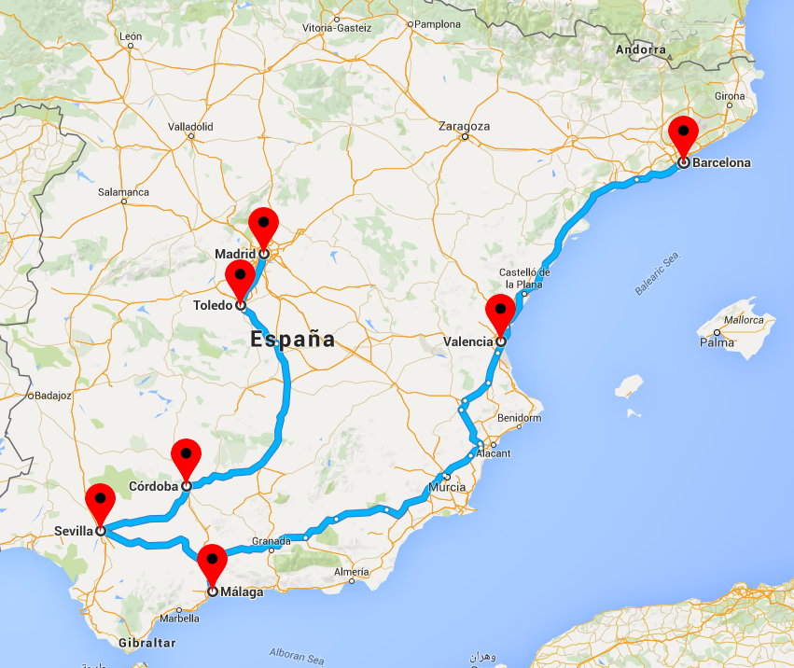

**1n**

**Madrid**

**2n**

**Málaga**

**2n**

**Valencia**

**2n**

**Sevilla**

**2n**

**Barcelona**